Barbell and Dumbells Pair, Weight 10 KG, Gym Weights Barbell / Dumbbells Set, Body Building Weight Set, Multiusage Set of Weight
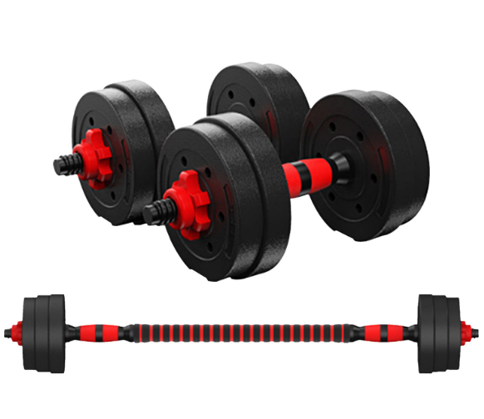

About this item
- BARBELL AND DUMBELLS | You will have 2 dumbbells bar and 1 Foam Barbell Rod includes in your set. You can remove or install the handlebar plates according to your needs. Perfect for your bodybuilding, muscle weight training, upper and lower body building exercises.
- QUALITY AND STURDY | It is made of high quality material and is durable and long lasting, high temperature resistance, anti-aging, high quality and durable.
- ANTI-SLIP DESIGN | Our dumbbell sets are designed with non-slip handles to prevent slipping during exercise and ensure a firm grip which is safer and more comfortable.
- EASY ASSAMBLY AND COMPACT DESIGN | Equipped with thick and smooth nuts that are easy to turn. The dumbbell set will not hurt your hands when assembling or using. After disassembly, it is easy to carry, also need a small storage space, suitable for home or office fitness training as you want.
- PACKAGE DETAILS | For Dumbbell Set: Total 10kg, 4x-1kg weight plates, 4x-1.5kg weight plates, 4x-Spin Collars, 2x-Dumbbell Bars, 1x-Foam Barbell Rod

Technical Details

Size | ‎10 KG
Material type | ‎Neoprene
Number of pieces | ‎2
Batteries included? | ‎No
Brand | ‎LMS Data
Manufacturer | ‎LMS Data
Manufacturer reference | ‎DUMB-BELL-SET-10 - FBM
Package Dimensions | ‎41.6 x 24.2 x 15.6 cm; 10.14 Kilograms
ASIN | ‎B09BNXGB9B

Warranty & Support
Amazon.com Return Policy:Regardless of your statutory right of withdrawal, you enjoy a 30-day right of return for many products. For exceptions and conditions, see Return details.

- Part number: ‎DUMB-BELL-SET-10
- Barcode number:5060838381096

